**Supply Inventory Instructions**

Last Updated April 12, 2017

**Basics**

In the mission office there is a supply closet where we keep all of the proselyting supplies such as scriptures and pamphlets. The office staff is responsible for distributing these proselyting materials to the missionaries as needed. The mission secretary is ultimately in charge of this task, but as of this date the office missionaries and office support sisters share in a lot of that responsibility.

**The Supply Cycle**

Generally, the office follows a monthly supply cycle as outlined below:

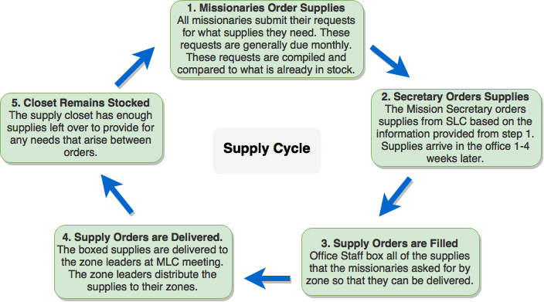

**Responsibilities of Office Missionaries**

Office missionaries have several duties concerning the supplies:

1. Throughout the supply cycle, we keep a running count of what it is in the supply inventory. This is important because we need to know when to order more supplies and how much we need to order.
2. We are solely responsible for step 1 in the supply cycle. We get the monthly supply requests from the missionaries, compile them, and compare them with what we already have in the inventory so that the Mission Secretary knows what and how much to order.
3. Office missionaries also help with organizing the supply closet and filling supply orders (step 1 in the cycle) as needed.

**The Supply Inventory System**

Step one in the cycle is especially tedious. Doing it by hand, it is very difficult and time consuming to coordinate the submission of 80+ supply requests, compile them, and then compare them to what we have in stock. To make the cycle (especially step one) much easier for everyone, Elder Parsons created a computerized system that does much of the work for you. In Google Drive, there is a folder called Supply Inventory. In that folder are several files:

* A folder called “Supply Order Archive”. This is where all of the past missionary supply orders are kept. When step 3 comes around, this is where you can see which zones ordered what so you can fill the requests.
* A spreadsheet called “Master Inventory”. This is the spreadsheet that tracks all of the supplies that come in and out of the office. It also calculates what supplies the mission secretary needs to order.
* A spreadsheet called “Supply Orders”. This is the spreadsheet that makes step 1 so much easier. This spreadsheet is shared with all of the mission Google accounts. When it is time for step 1 in the supply cycle, an office missionary can open this file, click “NJMM” in the menu, click “*Make Orders Available*”, and it will create hundreds of forms on the spreadsheet. Each companionship is to fill out their form on this spreadsheet before the orders are due (see the next section). When they are due, an office missionary goes to the same NJMM button and clicks “*Submit Orders*”. This compiles all of the data, erases all of the forms, and puts the totals in the Master Inventory spreadsheet to calculate what the mission secretary needs to order.

**Making The Supply Orders Sheet Available to the missionaries**

* After you click the “*Make Orders Available*” button (See the above bullet points) , you need to first rename the file to display the current month (ex: “April Supply Orders”), then move that same spreadsheet to the “NJMM All Shared” folder so that each companionship in the mission can access it and input their orders into their appropriate fields.
* Send out a mass text to all the missionaries informing them that the Supply orders are avaliable. There is no set format for these texts, but be sure to include where they can find the folder, when the deadline is, and to follow the instructions on the first tab.
* After the deadline is past (and all the missionaries have entered in their orders), continue with the instructions in the above bullet points by clicking the “*Submit Orders*”. Move it back to the Supply Inventory folder, and Rename the file back to “Supply Orders”